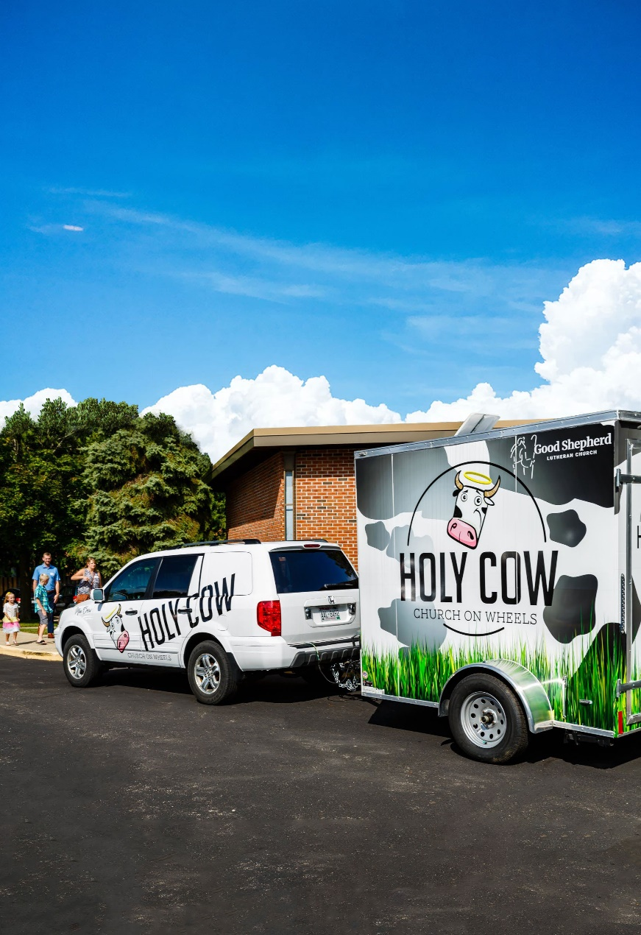
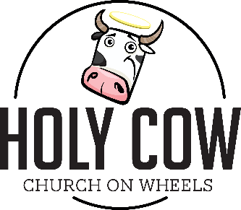
a ministry of

2024 Holy COW Food Truck Summer Intern

Apply online using the QR code below for the position of Holy COW Food Truck Intern from June -August 2024. The Holy COW is a pay-what-you-can food truck with a mission of sharing good food with anyone who needs it and supporting our community. Interns will work 12-16 hours per week prepping food, cooking, helping with the food truck calendar, assisting volunteers in cooperation with our staff members.

Applicants should have completed their junior year of high school by June 2024. All applicants must have reliable transportation to Good Shepherd Lutheran Church- Madison Campus (5701 Raymond Road, Madison, WI 53711), must be available during daytime and evening hours depending on our food truck schedule and must be comfortable working in a kitchen and outdoor setting or be willing to learn.

